**UCP EVV 2: EVV Overview – 11/21/19**

Electronic Visit Verification (EVV) is federally mandated to address concerns about fraud.

This change WILL NOT impact the services you receive or provide.

This change WILL impact the WAY you document the services you receive or provide.

There is a lot of important information to communicate and we will be sending out multiple emails over the next couple of weeks.

We want to be sure that we minimize any difficulty that will come with these changes, and we have developed training for you and will add additional resources based upon the feedback we receive.  You can find this training on the UCP AWC Training site. <http://training.ucptechcentral.org/agency-with-choice/training-agency-with-choice/>

1. EVV means AWC will be going paperless when documenting the services provided by the SSPs
2. Documentation of task completion will be done through the Mobile app
3. There will be no more signing or approval of paper timesheets by MEs
4. This ALSO means that the system has to have up-to-date schedules of all the SSPs who will be providing services

It is critical that all schedules are up-to-date at the time of service.  Every participant will have a schedule that is maintained by your Instructor in the EVV system.  The Instructor will maintain these schedules for you, but it is critical that all schedules are kept current.

YOU WILL NOT BE ABLE TO CHECK-IN to your schedule on the mobile app, if the schedule has NOT been communicated to the Instructor.  We recommend that if a schedule change is made that it is communicated immediately to the Instructor.

Schedule Changes

* If there are ANY schedule changes, contact your Instructor
* It is critical that all schedules are up to date at the time of service
* If the schedule has NOT been communicated to the Instructor, YOU WILL NOT BE ABLE TO CHECK-IN to a schedule and document your service
* If there is a last minute schedule change, you will need to contact your instructor immediately

EVV is a 5 step process for the SPP

1. Caregiver arrives and confirms the prior SSP has checked out
2. Caregiver checks-in using the mobile app
3. Caregiver documents service throughout session
4. Caregiver checks-out using the mobile app
5. Caregiver leaves

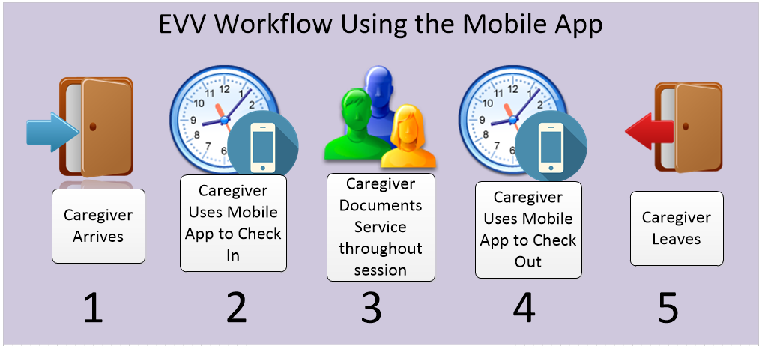

We have a video demonstrating this process that can be found on the training site.  We have a video demonstrating how to use the mobile app on the training site. <http://training.ucptechcentral.org/agency-with-choice/training-agency-with-choice/>.

SSPs will receive an email that will have the link to use to start the process to create their account.  Please watch for this email as it expires in 72 hours from when it is received.

Requirements to use the mobile app

1. Need to have access to a mobile device (smart phone or tablet), Apple or Android
2. The mobile device needs to have GPS
3. The mobile device needs to have location turned on for steps 2 and 4.

Some notes:

1. You can upload the schedules via WiFi or cellular data at a location other than the participants home
2. You can check-in or check-out without Wifi or cellular data and upload the data later at another location
3. The mobile device does not need to have data plan
4. You should add your task notes as you are performing the service
5. You should check off a task ONLY after you have entered the notes for the services performed
6. SSPs are paid based on the check in and out times

Thank you.